A000-Eur-Roman-Rhyton-Horse-Bronze-100 CE

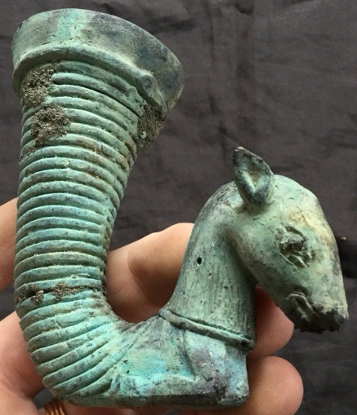

Roman-Rhyton-Horse-Bronze-100 CE

Bronze Roman Rhyton with a horse’s head. From a private British collection.

**Case no.: 4**

**Accession Number:**

**Formal Label:** Roman-Rhyton-Horse-Bronze-100 CE

**Display Description:**

**LC Classification:**

**Date or Time Horizon:**

**Geographical Area:**

**Map:**

**GPS coordinates:**

**Cultural Affiliation:**

**Media:**

**Dimensions:** H 10 cm x W 10 cm, Dia 4.5 cms

**Weight:** 194 **gm**

**Condition: original**

**Provenance:** From a private British collection.

**Discussion:**

**References:**

Koehl, R.B., 2006. *Aegean Bronze Age Rhyta*. Institute for Aegean Prehistory Press.